CURRICULUM VITAE

******************
Pr. Dr. Eng. CHERIF Adnane, Professor , FST

Director of the Research Laboratory ATSSEE

Responsible of Master studies SRT-FST
Coordinator of the Online Professional master TIC

Expert in E-Learning

1- Personal Information

Name : CHERIF
First name : Adnane Date of birth : 10/1/1963 State civilian : Married
Nationality : Tunisian
Email : Adnane.cherif@fst.utm.tn Adnen2fr@yahoo.fr
Such : 98 200809
2- Diplomas
1982 : Baccalaureate Math Technique
1987 : Diploma of Engineer ENIT
1991 : Master in Automatic & Electric Engineering
1997 : PhD Doctorate Thesis in Electric Engineering, ENIT , Tunisia
2002 : HDR, in Electric Engineering, ENIT.
3- Professional Experience

- Since January 2008 :
Senior Professor at the University of Tunis Manar, Faculty of Sciences of Tunis (FST)
- From 2002 to 2007
Maitre de Conferences, FST (associate Professor)
- From 1991 to 2002:
Assistant Professor at FST
- From 1988 to 1991:
Engineer at ENIT : Assistant of the Director of Department « Industrial Engineering »
4- Pedagogic Experiences

- Since 1991 : Teaching at FST (Faculty of Sciences of Tunis) in Master & license STIC, EEA, Engineering programs , and doctorate thesis
- 2008 to 2013 : coordination of the online Master at the virtual university of Tunis(UVT)

- development of tools E- learning on the Platform from EAD : moodle

- 2017 to 2024 : coordination and Education in the Professional Master SRT

5- Responsibilities

- Director of Department physical has there FST of 2008 has 2011.
- Director of the research laboratory « Electric and renewables energy systems» at the FST Since 2017
- President of there National committee of Promotion of professors of the Ministry of high studies and research 2016 And 2017
- Member of the National Committee of Recruitment of the Assistants during there period of 2006 And 2007.
- Coordinator of the Professionnal Master " system of communications» at FST Since 2003.
- Coordinator of virtual in line of the licenses STIC and Master Pro N2TR at the virtual university of Tunis from 2008 to 2013.
- Responsible of Master TIC in line with the National Center for Continuing Education and Professional Promotion CNFCPP since 2017
- Charged by the ministry DGRST for the assessment and evaluation of projects VRR 2017, VR2020, PAQ 2019, PEJC 2022 and PE2S 2023

- Member of there commission sectoral national of the studies And programs of training of engineers with of there DGET of MESRS

- Expert with the ANPR ( national Agency of research promotion) for the evaluation of projects and Post-doc candidates
- Expert in E-Learning
- Coordinator of teaching E-Learning in the virtual university from 2008to 2013
- Member of the committee of organization and reading of several conferences national And international (JT'99, CTGE2004, ICOSE2006, JTM2007, IPWis2011 & 2014, JCGE 2017, JCGE 2019, IC-ASET 2020 & 2021, 2023, ATSIP 2024, ….
- Representative of network Euro-Mediterranean MED-CAMPUS 15 in Tunisia during the period 1995 to 1998.

6- Experiences in certification and accreditation

  - Participation in international committees of program Evaluation & Accreditation
( ΝCΑΑΑ, ΑΤΕΑ, ...)
- Participating member of the FST committee for the accreditation for master's and engineering training of the cluster of computer science , Electronic and Communication Engineering 2023-2024

- Expert with ANPR (National Agency for the Promotion of Research) for the evaluation of research projects and post-doc, ARESSE green project

- Designed by the DGRS and the DGVR of the MESRS Ministry for the evaluation of VRR, PJEC, etc. research projects

- Member of there commission sectoral national of the studies And programs of training of engineers with of there DGET of MESRS.

7- Skills : training and certifications

- 2024: Training on Digital marketing
- 2023: Training on project management (AGILE, SCRUM, etc.)
- 2022: Training on the ISO 9001 and ISO 12001 quality management system
- 2021: Embedded LINUX certification training

8- Partnership and socioeconomic collaboration

8.1. R&D projects carried out

Year | Kind of project | Title of project
1995-1998 | MEDCAMPUS 15  (Partner) | Project of training Euro- Mediterranean: training on PV systems
2000-2002 | CMCU : cooperation Tunisia - French (Partner) | converters static multi levels
2009-2012 | Cooperation UTM-University of Nantes  (Partner) | thesis in joint supervision University of Rennes & Univ Tunis Manar :  CHERIF (Tunisia) + BASSEL S (Brest- France)
2011 – 2014 | Project of cooperation Tunisia - Moroccan PCTM 11TM38  (coordinator) | Follow up of the facilities electrification rural in Tunisia and to Morocco ( ATSSEE, FST , UTM + Univ Med5, FSO)
2017-2020 | Project of research valorization VRR  (coordinator) | Improvement of the penetration rate And integration ratio of the Renewables sources in Tunisian electric Network  (ATSSEE + MESRS + FST + STEG)
2017 & 2019 | AUF (Association University of the French-speaking countries) | Support for the organization of workshops  ( ATSSEE, UTM, FST , AUF)
2019-2023 | PAQ-Collabora  (coordinator) | Migration of STEG network towards smart grid  ( ATSSEE, FST, Tun Telecom, STEG, MESRS)
2020-2022 | Project COVID-19  (coordinator) | E-health application for elderly people ( ATSSEE, FST, AFA medical center , MESRS)
2022-2025 | Project H2020  Euro-African LEAP-RE  (Partner) | Hybrid PV solar cooker (Spain, Portugal, Italy, Germany, Tunisia, Algeria, Morocco)
2023-2024 | Project of excellence scientist P2ES (coordinator) | Smart green Agriculture
2024-2026 | Arab League ARICA Project (coordinator) | Sustainable development model for the management of energy and water resources in the Arab Maghreb (Tunisia + Algeria + Morocco + Libya )

8.2 . Signed agreements

Duration of there  convention | Partner | Object of convention
2017-2021 | ECOPARC  Park technological of Borj cedria | Incubation,Start up, valuation, Follow up of prototype, elaborations of  projects common
2016-2019 | Association "AFA » | Research, bases of data Internships of doctoral students
2017-2021 | C e nt r e of D ch e r c Hey s And d it is T ec hno L ogi e s d e  L ' In e r gi e CRTEn | Realization And measures experimental, Research And co -supervision of theses  and masters
2017 | STEG international | Development of applications in Renewable energy
2016-2020 | STEG | Internships, training, MOBIDOC,… Partner of Project PAQ-Collabora
2019-2023  renewal | Tunisia Telecom TT | Assistance , services of connection Partner of Project PAQ-Collabora
2017-2021 | Fac of the science from Oujda University Med first - Morocco | Thesis in joint supervision And Mobility of the researchers And of teachers
2017- 2019 | AUF (Association University of French-speaking countries) | Organization of conferences And of demonstrations scientists
2018-2023  renewal | Horizon-Data company | Start-up For there bet in open And there realization of our prototype
2021-2026 | CETIME | Certification of the products, Assistance And expertise And subcontracting
2022-2025 | ACTIA | Opening socioeconomic Projects common  Co-Supervision
2022-2026 | University of Lougborough -GB | Support financial And of nature Of the projects Horizon Europe
2023-2025 | ANPR : Agency National of Promotion of there Research | Assembly common of a lab pilot PPI4

8.3. Coopération with international Laboratories

Nom du laboratoire | Directeur | lieu | université | Type et objet de coopération
LETSER | Pr Kassmi Khalil | Faculté des Sciences d’Oujda | Université de Med premier Maroc | Une convention est établie entre les deux labos (cotutelle + projet R&D + mobilté)
Electric Power Systems and Microgrids | Pr Gerrero J.M | - Faculty of Engineering and Science de Alborg | Alborg  Danemark | Mobilité , Stage de recherche & projet de recherche & publications communes
SAMOVA  CNRS- UM5505 | Pr. Julien Pinquier | IRIT- Toulouse | Université Toulouse III  Paul sabatier | Projet de recherche  (projet Utique)
L2P- Lille | Pr. Bruno FRANCOIS | Ecole Centrale de Lille | Université de Lille | Mobilité des enseignants et doctorants
POLARIS  IETR, CNRS | Pr. MERIC Stéphane | INSA-Rennes | Université de Rennes | En cours de développement  (co-encadrement & thèse en co-tutelle & mobilité, montage de projets
IMT Atlantique – labo ITI | Prof. BASSEL.S | ESTTB Telecom Bretagne | Université de Nantes | Co-tutelle de thèse  dans le domaine d’imagerie médicale
(ITM-CNR)  National Research Council of Italy | Alberto Figoli | ISTITUTO DE TECNOLOGIA | Università della Calabria | Mobilité , publications communes, projet R&I
FHR de Franhoover | Dr. Reinhold Herschel | Fraunhofer Institut fur HochfrequenzphysikundRadar technik | Franhoover  Allemagne | Echange de stages et doctorants  Co-encadrement  Projet de recherche TUNGER

8.4. Patent

  - Patent for autonomous electric car powered by green hydrogen powered by PEMFC
Ref : TN2023/0007 of 12/1/2023
Google Drive link of the prototype of the hydrogen electric car from the lab

https://drive.google.com/drive/folders/1LBfO9uiz9QKho8xeeT_H8lW9Fzc70YwN

9- Langages

  - Arabic: (read, written and spoken)
  - French: (read, written and spoken)
  - English: (read, written and spoken)

10- social and association activities

  - Member of the Association of Electrical Specialists of Tunisia ASET
  - Member of the FST university teachers association

11- Scientific Production

  - 132 publications in indexed and impacted journals
  - 65 communications in International conferences

  - 03 published Books (CPU)
  - 02 online Courses on the platform www.uvt.rnu.tn

  - 46 thesis of doctorates supported under my direction & supervision
  - 38 Masters of research (supported)

  - 55 Professional Masters STR (supported)
13. Visibility through mass medias and social networks

- Reporting turned & broadcast on the national TV Watania 1 , 8/3/2023 at 8 p.m.
link of there video : https://drive.google.com/file/d/1-rpEt_zTfI9SnDW4c5rElj3kMqPJrcyH/view
  - Reporting on the radio national chain « Youth radio » on 7/4/2023

web Sites of the laboratory :

https://utm.rnu.tn/visirech/Fr/utm/fst/atssee/

https://sites.google.com/view/atssee

Pages of ATSSEE lab on social networks FB, Researchgate and Linkedin :
Facebook : https://www.facebook.com/atssee.fst/​

Researchgate : https://www.researchgate.net/profile/Atssee-Fst​

linkedIn : https://www.linkedin.com/in/atssee-fst-6a99aa1b9/​

14- Publications (last 5 years )

Titre | Auteurs | année | Journal
Modeling and Simulation of a Renewable Energy PV/PEM with Green Hydrogen Storage  https://www.etasr.com/index.php/ETASR/article/view/6492 Doi : https://doi.org/10.48084/etasr.6492 | D. Hidouri, R.marouani & A.cherif | 2024 | ETASR , Vol. 14 No. Pp :12543-12548 , 2024
The Performance of Stable Zones Protocol for Heterogeneous Wireless Sensor Networks  https://www.etasr.com/index.php/ETASR/article/view/7716 doi : https://doi.org/10.48084/etasr.7716 | Khdhiri K., Djabbour K., cherif A. | 2024 | ETASR Vol. 14 No. 4 , pp :15876-15881, 2024
Design and Implementation of a Smart PV Hydroponic Greenhouse for Sustainable Agriculture in Tunisia | R. Marouani,M. chakabata M, bouadila S, S. khachroumi, cherif A | 2024 | ETASR , vol 14(3), pp:144411-144419, 2024
A New Robust Blind Crypto-Watermarking Method for Medical Images Security  http://paper.ijcsns.org/07_book/202403/20240311.pdf | M. boussif M.boufares, N. Aloui, A.Cherif | 2024 | IJCSNS Int.Journal of Computer Science and Network Security, VOL.24 No.3, 2024
Real-time voice-controlled human machine interface system for wheelchairs implementation using Raspberry Pi  Doi : https://doi.org/10.1504/IJVICS.2024.136273  https://www.inderscienceonline.com/doi/abs/10.1504/IJVICS.2024.136273 | A.Mnassri, S. Nasri, M.boussif & A.cherif | 2024 | International Journal of Vehicle Information and Communication Systems. Vol. 9, No. 1,pp81-102, 2024
Effects of Temperature and Solar Irradiation Variations on The Performances of Photovoltaic Pumping Systems  Doi: https://doi.org/10.54963/neea.v3i1.244  https://ojs.ukscip.com/index.php/neea/article/view/244 | Jraidi M, cherif A | 2024 | - New Energy Exploitation and Application, Vol 3 Issue 1: June 2024 /
Fatigue detection in a smart car driving  Doi : 10.1109/IC_ASET61847.2024.10596184  https://ieeexplore.ieee.org/abstract/document/10596184 | A.Jouini, B. Lamia, A. cherif | 2024 | IEEE conference IC-ASET2024
Detection and Classification of Neurodegenerative Diseases by Automatic Speech Analysis  https://ieeexplore.ieee.org/document/10638844  DOI : 10.1109/ATSIP62566.2024.10638844 | A.Kehili, B.Lamia, A. cherif | 2024 | IEEE conference ATSIP 2024  July 11-13, 2024
Smart Grid 2.0: Modeling Peer-to-Peer Trading Community and Incentives for Prosumers in the Transactive Energy Grid | - M.M. Khayyat, S.Ben Slama | 2024 | ETASR , Vol. 14 No. 2 April 2024

Early Detection of Alzheimer's Disease Using VOT Mean Measure in New Tunisian Arabic Database | Dabbabi karim  Khili Ahlem  Cherif Adnen | 2023 | IEEE International Conference on Advanced Systems and Emergent Technologies IC_ASET, Hammamet
ADAS and 5G/6G-V2X implementation for Sustainable and Intelligent Transport , | Anis.Jouini, Dalila Hidouri & Adnane.Cherif | 2023 | 22nd Mediterranean Microwave Symposium ,MMS 2023, Tunis , October 2023
ERP evaluation of EEG signals for monitoring anesthesia depth during surgery | B.Lamia | 2023 | Biomedical Research and Therapy, Vol 10 No 10, pp:5995-6008, 2023.  https://bmrat.biomedpress.org/index.php/BMRAT/article/view/841
A Smart Wheelchair for Autonomous Movements of Disabled People | B.Lamia, A cherif | 2023 | International Conference on Academic Studies in Technology and Education ICASTE’23, Antalya 2023
Integration of Renewable Energies into the Smart Grid Electricity network | B.Lamia, A cherif | 2023 | IEEE International Conference on Artificial Intelligence & Green Energy (ICAIGE), October 2023  DOI: 10.1109/ICAIGE58321.2023.10346488
A Review of Non Invasive Methods of Brain Activity Measurements via EEG Signals Analysis | D. Turkia, B.Lamia, A cherif | 2023 | IEEE International Conference on Advanced Systems and Emergent Technologies (IC_ASET), 2023
Innovative Grid-Connected Photovoltaic Systems Control Based on Complex- Vector-Filter | Mansouri Nouha SihemNasri; Abderez ak Lashab; Josep M. Guerrero;A Cherif | 2022 | Energies  DOI: 10.3390/en15186772
Electric Vehicle Energy Management Strategy Geared to Smart Cities | khadhraoui A., Cherif, A. | 2022 | Advances in Intelligent Systems Research, vol 175, pp. 144–150
New Backstepping-DSOGI hybrid control applied to a Smart-Grid Photovoltaic System | Nebilisalim, ben abdallah I, Cherif Adnen | 2022 | IJCSNS International Journal of Computer Science and Network Security, Vol.22 No.4, April 2022
Energy Management and Performance Evaluation of Fuel Cell Battery Based Electric Vehicle | khadhraoui  A., SelmiTarek,Cherif, A. | 2022 | IJCSNS International Journal of Computer Science and Network Security, VOL.22 No.3, March
Energy Management of a Hybrid Electric Vehicle | khadhraoui  A., SelmiTarek,Cherif, A | 2022 | Engineering, Technology & Applied Science Research. Vol. 12, No. 4, 2022, pp 8916-8921
Advanced real time IoT Eco-Driving Assistant  System | Jouini A, Hasnaoui S, A.Cherif | 2022 | IJCSNS International Journal of  Computer Science and Network Security, Vol.22 No.4, April 2022
Comparative Study of patch antennas for  C-V2x Communication | Jouini Anis, Hasnaoui  S, A. Cherif | 2022 | In Proceedings of IC_ACET  conference , Hammamet, Tunisia,

Performance analysis and multi-mode control  of grid connected micro Wind–solar hybrid generator in Saudi Arabia, | Sami Younsi, Omar  Kahouli, NejibHamrouni, Haitham Alsaif, Ali Aloui&Sameir Hamed | 2022 | Journal of Taibah University for  Science, 16:1,550-565, DOI: 10.1080/16583655.2022.2078134
How to avoid partial implantation of people  with cochlear malformation | Bouafiflamia Cherif Adnen | 2022 | ARCHIVES OF CANCER SCIENCE AND THERAPY, vol 6, pp 36-38,
Decoupling Control Applied to the Smart Grid Power Dispatching Problem | S. Nebili, I. Benabdallah, and A. Cherif | 2022 | Engineering,Technologyand Applied Science Research, vol. 12, no. 4, pp. 8960–8966, Aug. 2022.
Fuel cell–based electric vehicles technologies  and challenges | khadhraoui A.,  SelmiTarek, Cherif, A. | 2022 | Environmental Science and Pollution  Research  Vol 29 , 2022
A Theoretical Study on the Simultaneous Hydrogen Production and Consumption in Proton Exchange Membrane Fuel  Cell/Battery Electric Vehicles | Khadhraoui, A., Selmi, T., Cherif, A., Iulianelli, A. | 2022 | International Journal of Membrane Science and Technology, 2022, vol 9,  pp. 90–100
PV-EV integrated home energy management using vehicle-to-home (V2H)technology and  household occupant behaviors | Sami slama | 2022 | Energy strategy reviews Vol 44, 2022
Novel Training Methods Based Artificial Neural Network for the Dynamic Prediction  of the Consumed Energy | Farhat, A.B., Cherif, A. | 2022 | Lecture Notes in Computer Science  , 2022, 13119 LNAI, pp. 210–217

Adaptive filter based on Monte Carlo method to improve the non-linear target tracking in the radar system | Zarai, K., Cherif, A. | 2021 | Aerospace Systems, vol 4(1), pp. 67–74
Early Detection of Parkinson’s and Alzheimer’s Diseases Using the VOT_Mean Feature | AhlemKehili, dabbabiKarim, Cherif Adnen | 2021 | Engineering, Technology & Applied Science Research Vol. 11, No. 2, 2021, 6912-6918
Related review of the smart metering in a smart home and smart grid  applications | M. Jraidi, A. Cherif | 2021 | Book chapter , CRC Press ISBN : 9781003181545
Intelligent Traffic Light Controller using Fuzzy Logic and Image Processing | Chabchoub, A Hamouda, A Cherif, A | 2021 | INTERNATIONAL JOURNAL OF ADVANCED COMPUTER  SCIENCE AND APPLICATIONS, vol 12 (4) ,
A real time software tool for 2d/3d  antenna radiation pattern | Jouini, A., Hasnaoui,  A., Mejri, F., Cherif, A., Hasnaoui, S. | 2021 | PrzegladElektrotechniczny, vol  97(11),  pp. 195–199
A Novel Second Order Radial Basis  Function Neural Network Technique for Enhanced Load Forecasting of Photovoltaic Power Systems | Arwa Ben Farhat , S.Singh Chandel , WaiLok Woo, Cherif | 2021 | International Journal of Computer  Science and Network Security, Vol.21, No.2, February 2021
A Novel Robust Blind  AES/LWT+DCT+SVD-Based Crypto- Watermarking schema for DICOM Images Security | Boussif, M.,  Bouferas, O., Aloui, N., Cherif, A. | 2021 | 3rd IEEE International Conference  on Design and Test of Integrated Micro and Nano-Systems, DTS’ 21

Moving Object Detection System Based  on the Modified Temporal Difference and OTSU algorithm | Boufares, O., Boussif,  M., Aloui, N. | 2021 | 18th IEEE International Multi-  Conference on Systems, Signals and Devices, SSD 2021, 2021, pp.  1378–1382, 9429516
Design and implementation of home energy management system using  vehicle to home (H2V) approach | Ben Slama, S. | 2021 | Journal of Cleaner Production, vol 312,
New strategy to enhance AC grid performance with SVC device in an optimal location | Mohamed,  M., Merzoug, Y., Sami, Ben Slama. | 2021 | Journal of Ambient Intelligence and Humanized Computing,  DOI: 10.1007/s12652-021-03568- 0
Smart Home Energy Management System: A Multi-agent Approach for Scheduling and Controlling Household  Appliances | Sultan, Y.A., Sami B.Slama., Zafar, B.A. | 2021 | International Journal of Advanced Computer Science and Applications, 2021,12(3), 237-244
Review of dc-ac converters for photovoltaic conversion chains | Bouzguenda M, Selmi Tarek. | 2021 | International Journal of Power Electronics and Drive  Systems, 2021, 12(2), pp. 886–901

Real-time implementation of an  optimized speech compression system in STM32F4 discovery board | Bousselmi, S., Saoud,  S., Cherif, A. | 2020 | Smart Innovation, Systems and  Technologies. Vol 147, pp. 37-48
DSP real-time implementation of DOST  algorithm used for speech enhancement | Saoud, S., Bousselmi,  S., Nasr,  M.B., Cherif, A. | 2020 | Smart Innovation, Systems and  Technologies  Volume 147, 2020, Pages 77-88
Hand Sign Language Feature Extraction  Using Image Processing | Chabchoub,  A., Hamouda, A., Al-  Ahmadi, S., Barkouti, W., Cherif, A. | 2020 | Advances in Intelligent Systems and  Computing  Vol 1070, pp. 122-131
Coordinated scheduling of fuel cell-  electric vehicles and solar power generation considering vehicle to grid bidirectional energy transfer mode | Sami, B., Sihem,  N., Bassam,  Z., Adnen Cherif. | 2020 | Lecture Notes in Networks and  Systems ; Vol 69, pp. 291-303
An Efficient External Energy Maximization-based Energy  Management Strategy for a Battery/Super capacitor of a Micro Grid | M Dhifli, S Lashab, JM Guerrero, Cherif | 2020 | IJCSNS journal Vol 20 (1), pp  196-201
Early Parkinson Detection Using Fully-  Connected Deep Neural Network based on Vocal Features | AhlemKehili,  dabbabiKarim, Cherif Adnen | 2020 | International Journal of Computer  Science and Network Security Vol. 20 No. 6 pp. 132-143

Innovative automatic discrimination multimedia documents for indexing using hybrid GMM-SVM method | Turkia, D., Souha, B., Adnen Cherif. | 2019 | International Journal of Advanced Computer Science and Applications 10(1), pp. 274-279, january 2019
Speech/Non-speech Discrimination for  Broadcast Radio Using Entropy Energy Modulation | DebabiTurkia, Cherif  Adnen | 2019 | IJCSNS: International Journal of  Computer Science and Network 140 Security VOL.19 No.4, 140-145
Modeling and Simulation of Renewable  Generation System: Tunisia Grid Connected PV System Case Study | Mansouri,  N., Bouchoucha, C., Cherif, A. | 2019 | Smart Innovation, Systems and  Technologies  Vol 150, pp. 316-322, 2019

Hybrid Feature Extraction Techniques  Using TEO-PWP for Enhancement of Automatic Speech Recognition in Real Noisy Environment | Helali, W., Hajaiej, Z., Cherif, A. | 2019 | Smart Innovation, Systems and Technologies  Vol 150, pp. 190-195, 2019
Improved industrial modeling and harmonic mitigation of a grid connected steel plant in Libya | Oun,  A., Benabdallah, I., Cherif, A. | 2019 | International Journal of Advanced Computer Science and Applications Volume 10, Issue 2, 2019, pp101-  109
Improve the Tracking of the Target in  Radar System Using the Particular Filter | Khaireddine,  Z., Sami, B.S.,  A, Cherif. | 2019 | Smart Innovation, Systems and  Technologies  Vol 150, pp. 55-62
A Predictive Real-Time Energy  Management Control for aÂ Hybrid  PEMFC Electric System Using Battery/Ultracapacitor | Sihem, N., Sami,  B.S., Zafar,  B., Adnane Cherif | 2019 | Smart Innovation, Systems and  Technologies  Vol 150, pp. 258-265
Performance Evaluation of an Appraisal  Autonomous System with Hydrogen Energy Storage Devoted for Tunisian  Remote Housing | Sami, B.S., Sihem,  N., Zafar, B., Adnane Cherif., Elangar A | 2019 | Smart Innovation, Systems and  Technologies vol 150, pp. 274-281
A dual-channel speech enhancement method for cellular communication | Nabi, W., Aloui, N., Cherif, A. | 2018 | 4th International Conference on Advanced Technologies for Signal  and Image Processing, ATSIP 2018
Voice pathology recognition and classification using noise related features | Hamdi, R., Hajji, S., Cherif, A. | 2018 | International Journal of Advanced Computer Science and Applications 9(11), pp. 82-87
A dual-channel noise reduction  algorithm based on the coherence function and the bionic wavelet | Nabi, W.; Ben Nasr,  M.; Aloui,  N.; Cherif, A | 2018 | Applied Acoustics  10.1016/j.apacoust.2017.11.003
Arabic corpus implementation: Application to speech recognition | Helali, W., Hajaiej, Z., Cherif, A. | 2018 | 2018 International Conference on Advanced Systems and Electric  Technologies, IC_ASET 2018 pp50-53
Improved design of an adaptive massive  MIMO spherical antenna array | Kamali, M.; Cherif, A | 2018 | International Journal of Advanced Computer Science and Applications  10.14569/IJACSA.2018.091259
Secured cloud computing for medical  data based on watermarking and encryption | Boussif, M.; Aloui,  N.; Cherif, A. | 2018 | IET Networks journal  DOI: 10.1049/iet-net.2017.0180
A dual-microphone noise  reductionalgorithm for mobile communications | Nabi,  W., Noureddine, A., Cherif, A. | 2017 | 7th International Conference on  Sciences of Electronics,  Technologies of Information and Telecommunications, pp. 258-262
New Watermarking/Encryption Method for Medical Images Full Protection in m-  Health | Md Boussif , Nourredinne Aloui ,  Adnene Cherif | 2017 | International Journal of Electrical and Computer Engineering (IJECE)  Vol. 7, No. 6, pp. 3385~3394
Grid Connected PV Plant based on Smart Grid Control and Monitoring | Oun,A., Benabdallah, I., Cherif, A. | 2017 | International Journal of Advanced Computer Science and Applications,  Vol. 8, No. 6, 2017
Improved Modeling and Control of a HTA Grid Connected 500 KW PV Systems | Ben abdallah,  I., Cherif, A. | 2017 | Indian Journal of Science and Technology, Vol 10(27), DOI:  10.17485/ijst/2017/v10i27/116134,

Integration of evolutionary computation algorithms and new AUTO-TLBO technique in the speaker clustering stage for speaker diarization of broadcast news | Dabbabi, K., Hajji, S., Cherif, A. | 2017 | Eurasip Journal on Audio, Speech, and Music Processing  2017(1),21
Energy-efficient routing protocol to improve energy consumption in wireless  sensors networks | Elkamel, R., Cherif, A. | 2017 | International Journal of Communication Systems  30(17),e3360
Smartphone application for medical images secured exchange based on encryption using the matrix product and  the exclusive addition | Boussif, M., Aloui, N., Cherif, A. | 2017 | IET Image Processing 11(11), pp. 1020-1026
An improved speech enhancement  algorithm for dual-channel mobile phones using wavelet and genetic Alg. | Nabi, W., Aloui, N., Cherif, A. | 2017 | Computers and Electrical Engineering  62, pp. 692-705
Autonomous hybrid system and coordinated intelligent management approach in power system operation  and control using hydrogen storage | Nasri, S., Ben Slama, S., Yahyaoui, I., Zafar, B., Cherif,A | 2017 | International Journal of Hydrogen Energy  42(15), pp. 9511-9523
Design of a command scheme for grid  connected PV systems using classical controllers | Hamrouni, N., Jraidi,  M. Dhouib,A.Cherif, | 2017 | Electric Power Systems Research 143, pp. 503-512

ANNEXES

Presentation of the results of the projects VRR & PAQ-Collabora of lab ATSSEE has there fair of innovation 2023

With there boss of government
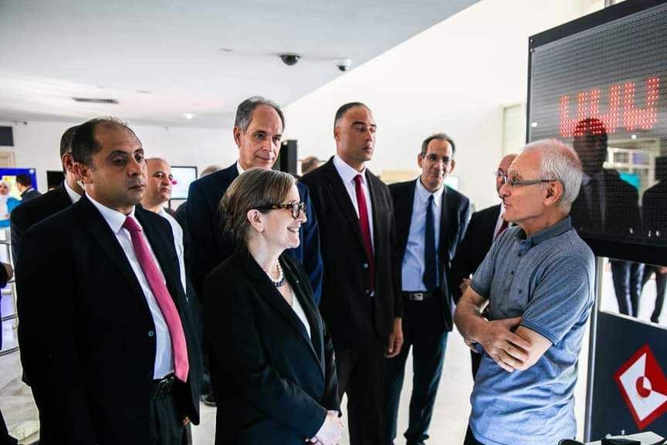

With THE ministers of teaching superior, THE minister of there Health And THE minister of education
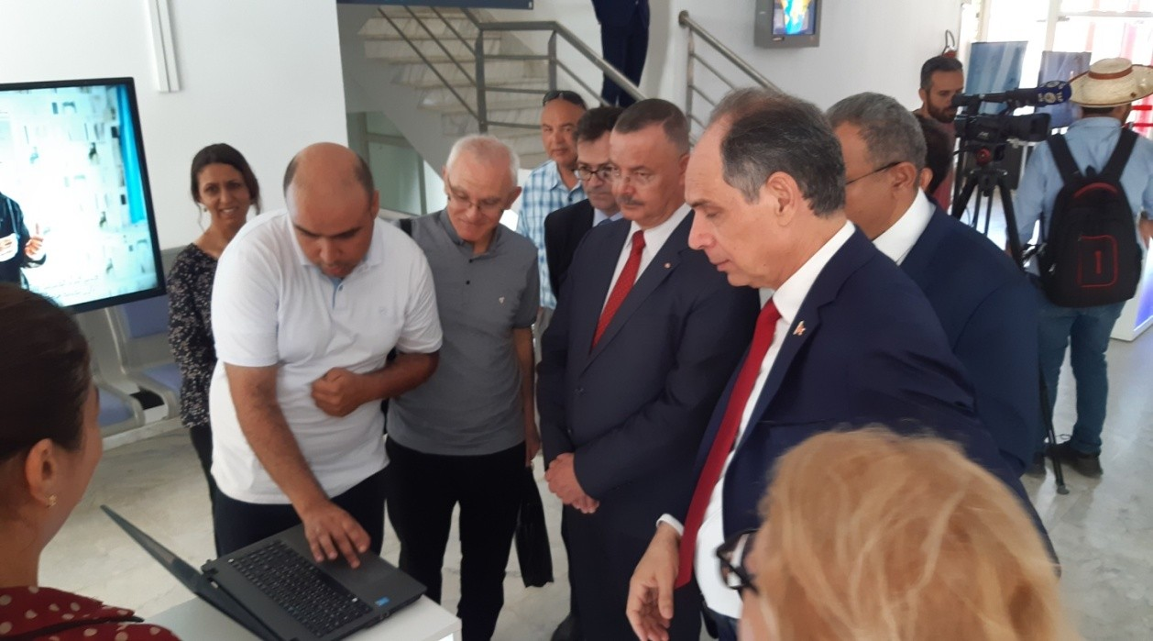

Reporting turned And broadcast on there chain TV national : Watania 1, THE 8/3/2023 at 8 p.m.
link of there video :
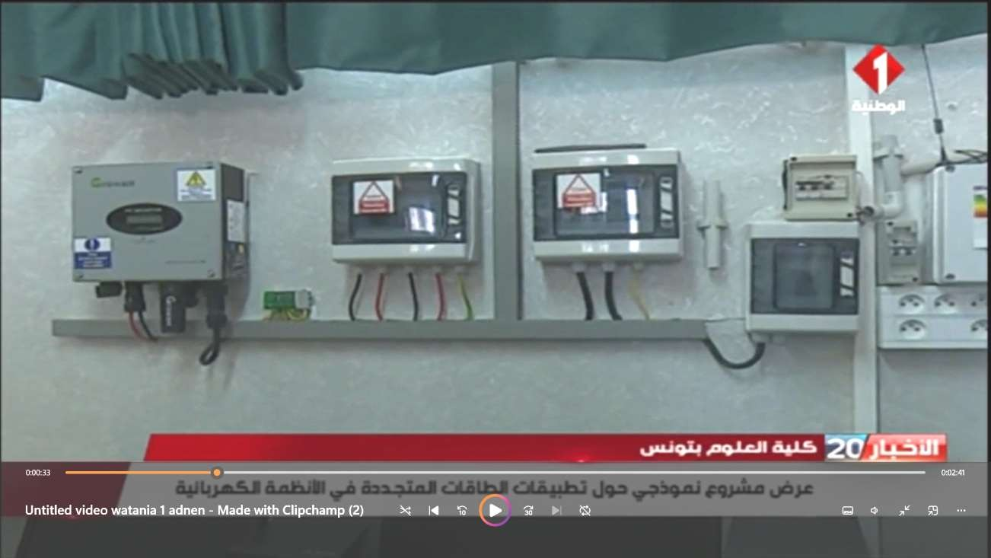
https://drive.google.com/file/d/1-rpEt_zTfI9SnDW4c5rElj3kMqPJrcyH/view

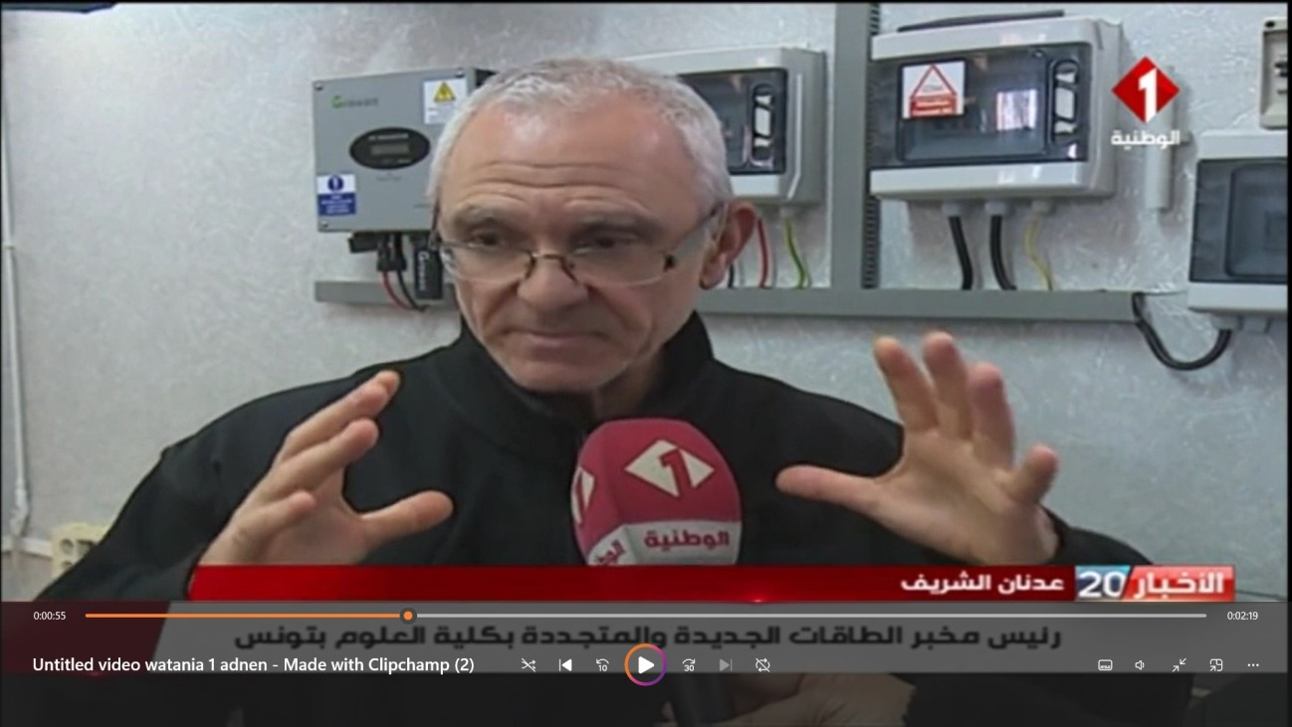

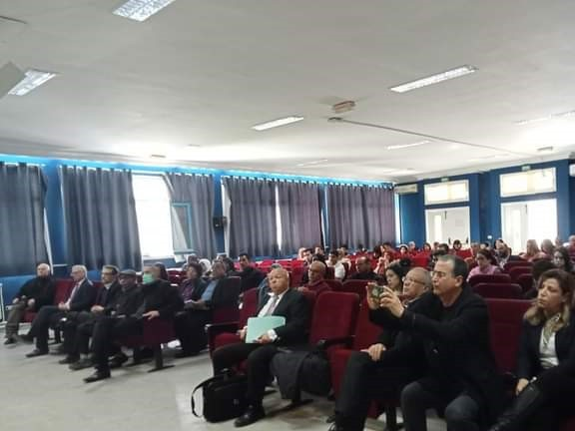

Reporting on Radio Young people Tunisia (Page official) : at 7/4/2023
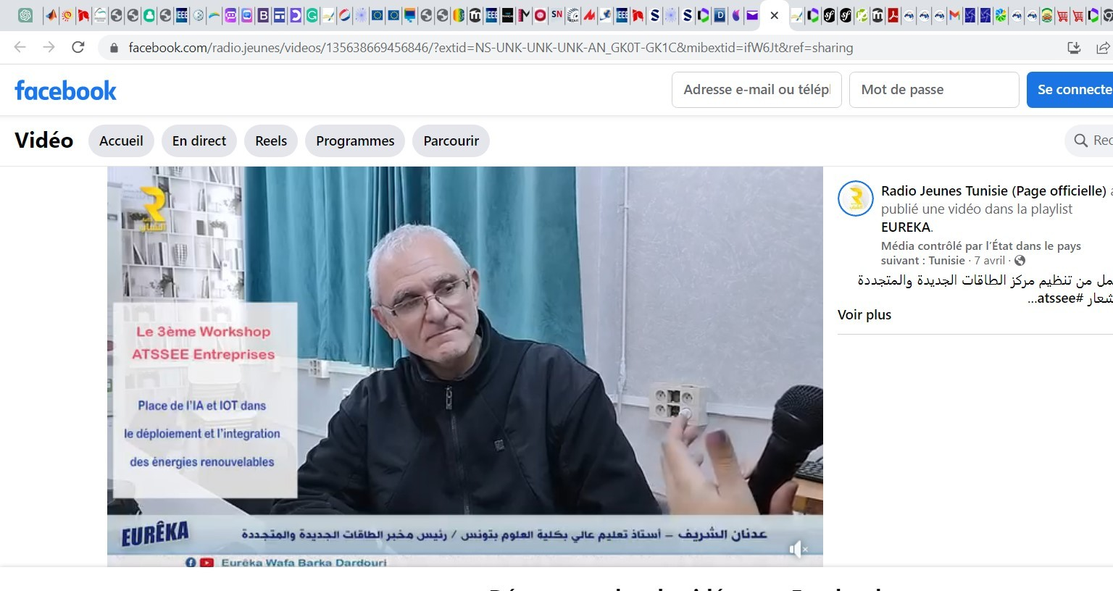

Images from the laboratory
and projects

websites of the lab:

https://utm.rnu.tn/visirech/Fr/utm/fst/atssee/

www.atssee.tn

https://sites.google.com/view/atssee

Entrance door to the laboratory

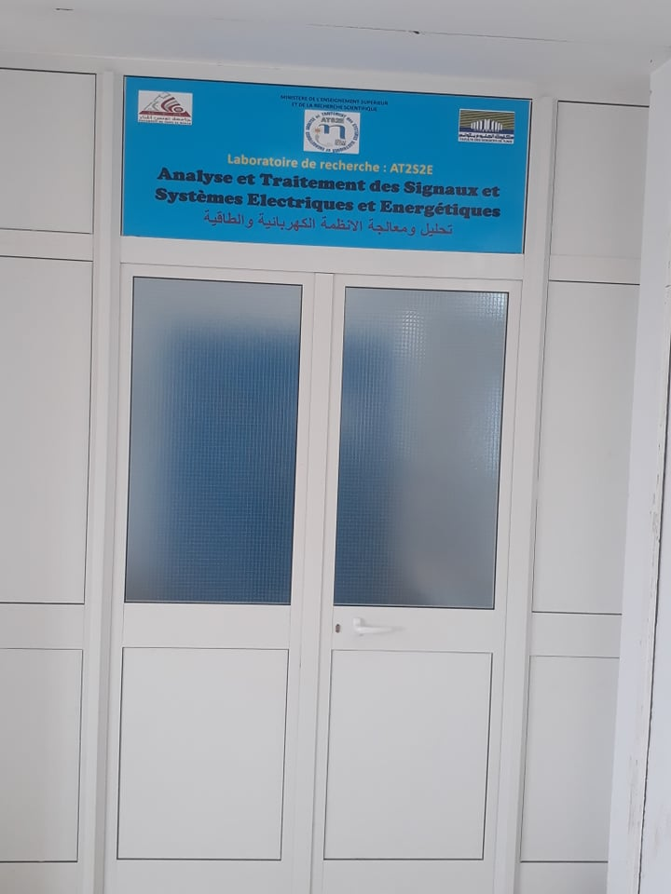

Inverters and data acquisition chains

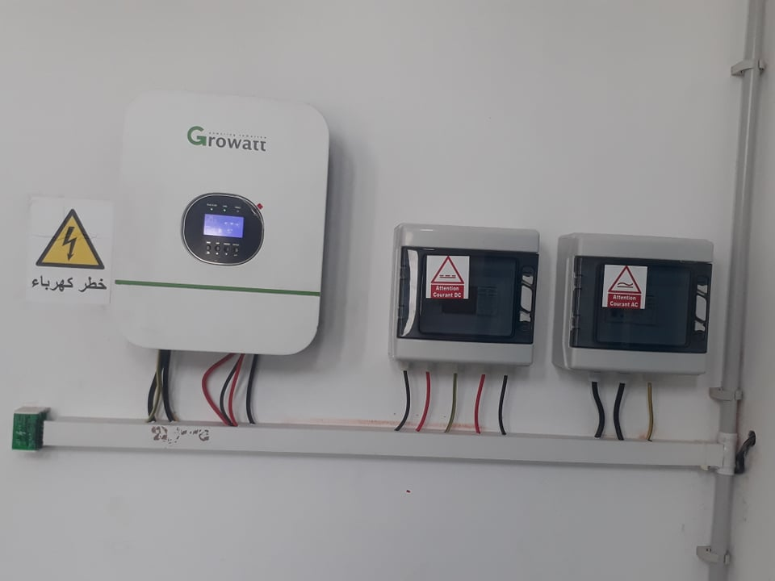

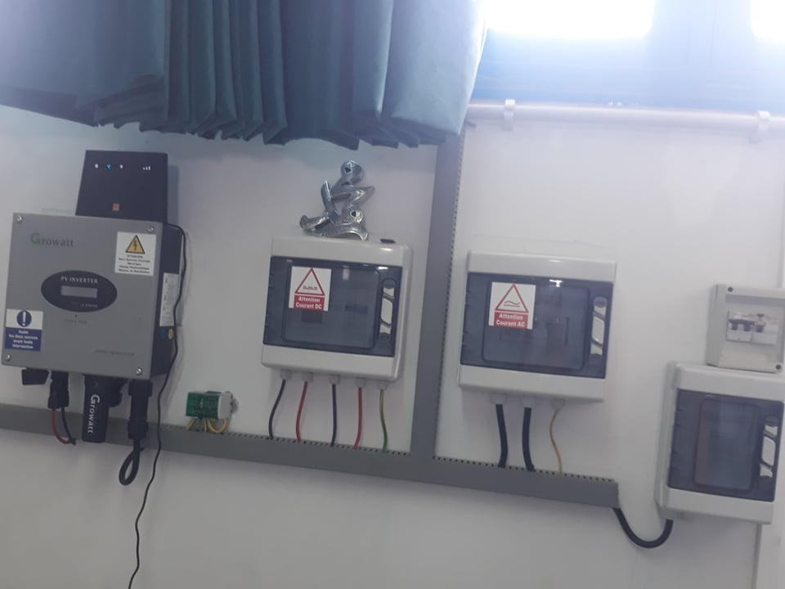

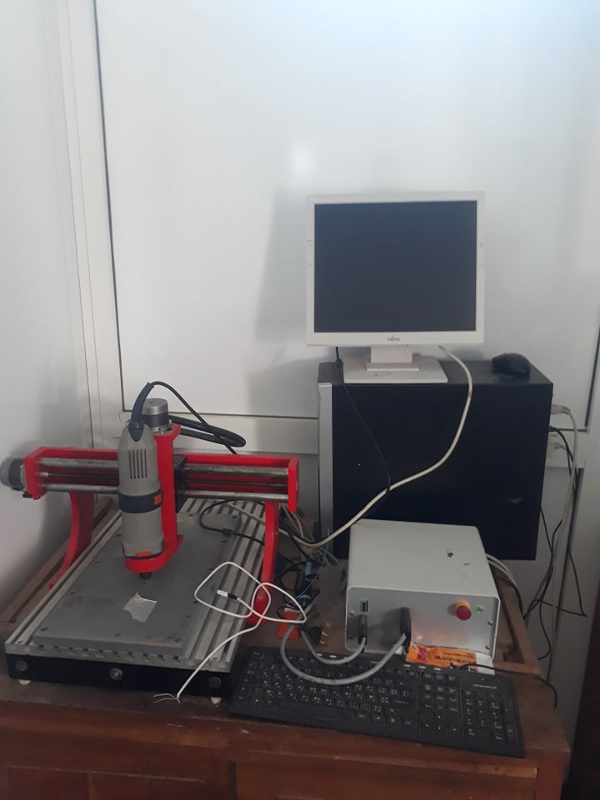

PCB machine
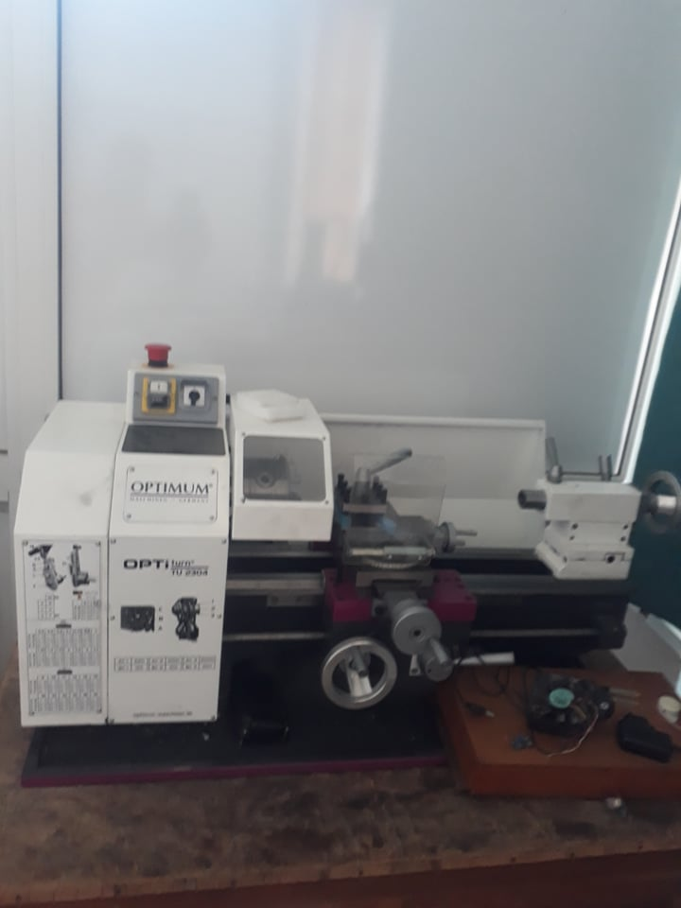

Horizontal tower machine

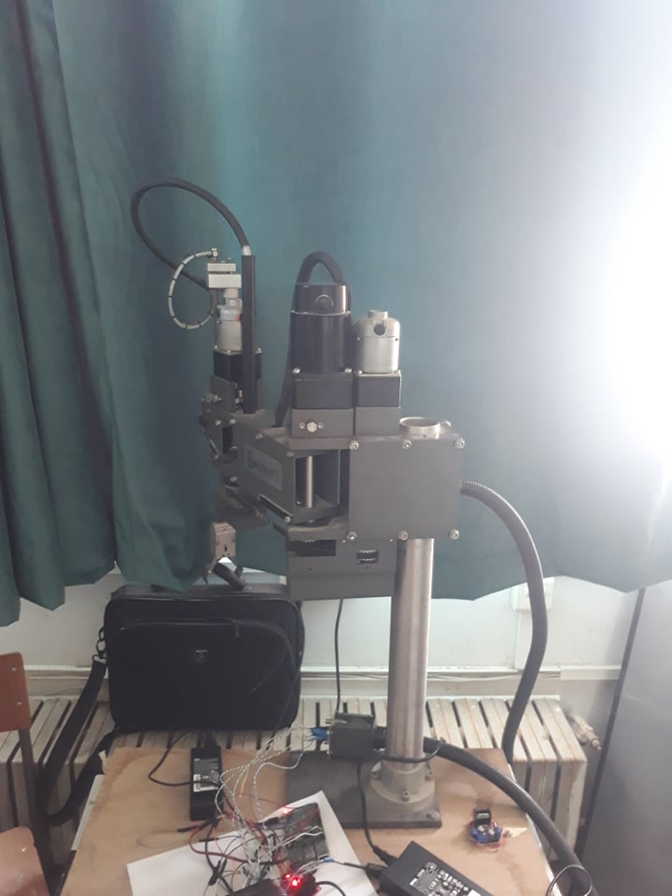

Robot with manipulator arm
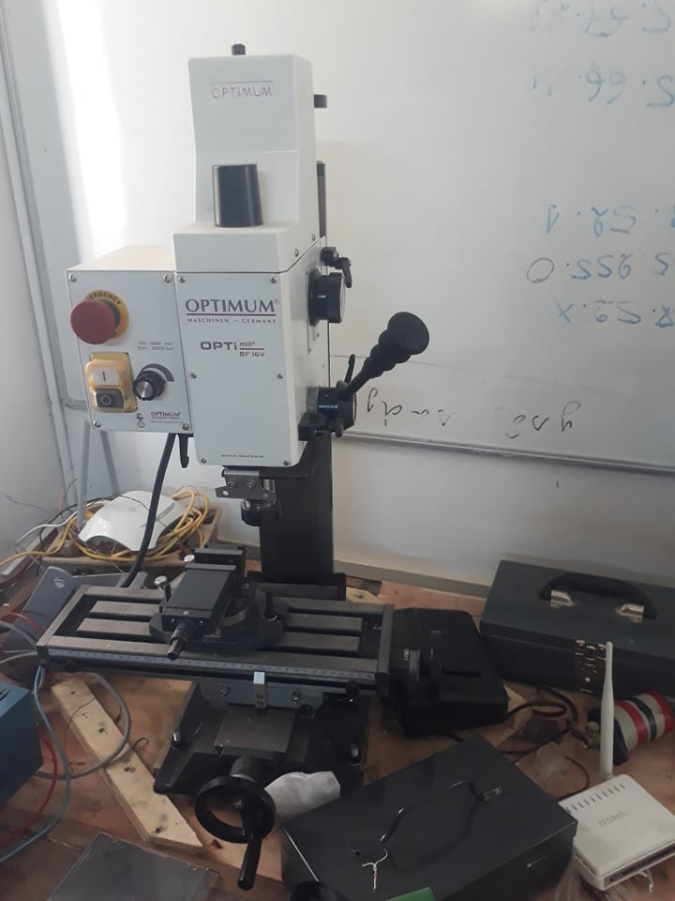
Machine Fraiseuse/Perceuse

3 KW hybrid station: PV and wind

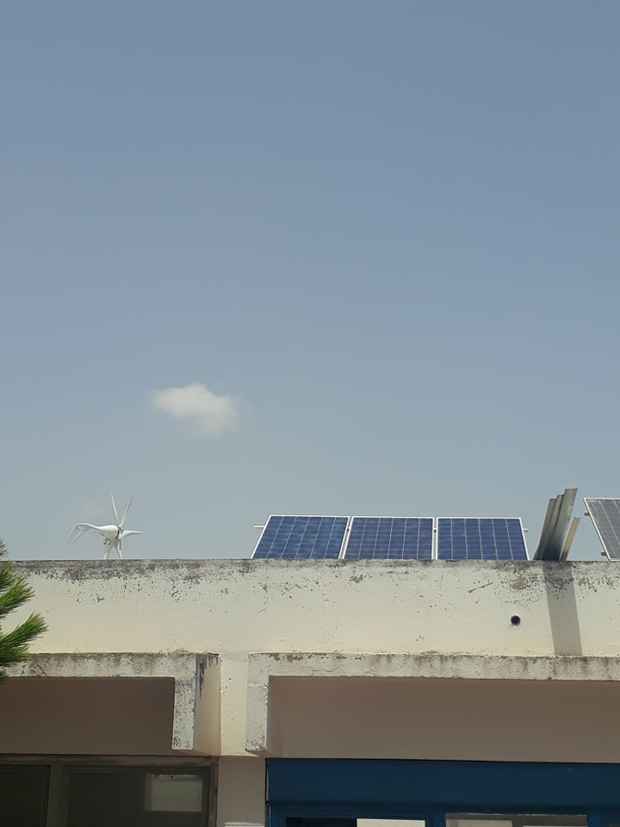

3 KW grid connected amorphous PV station

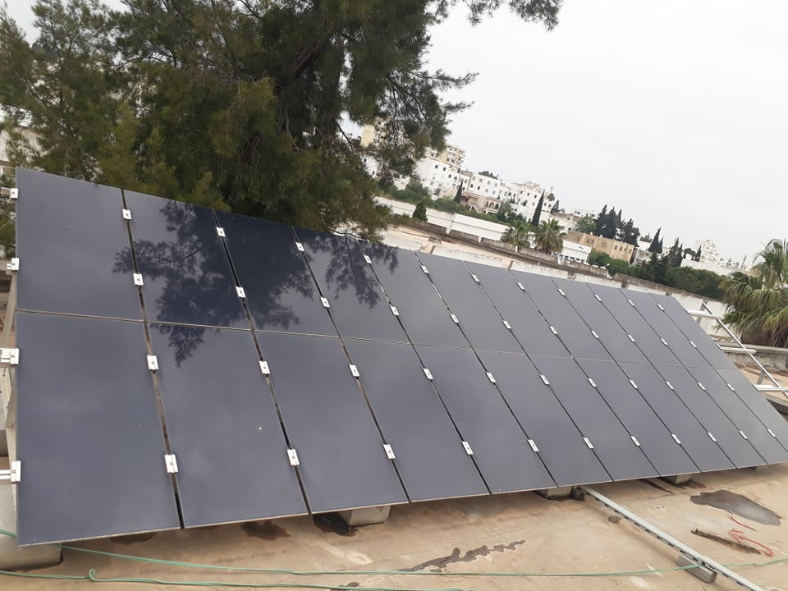
Hybrid Solar Wind station
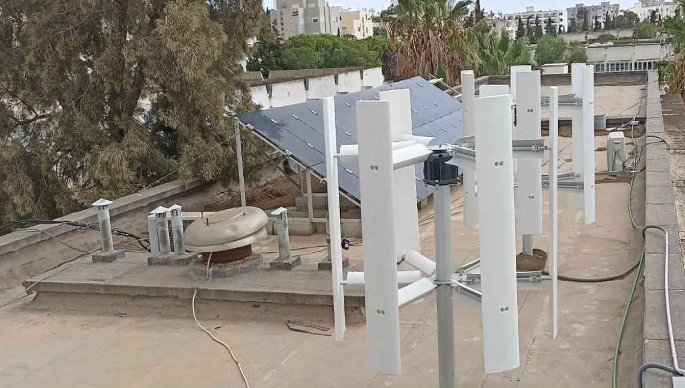

Green Hydrogen vehicle prototype developed in the lab

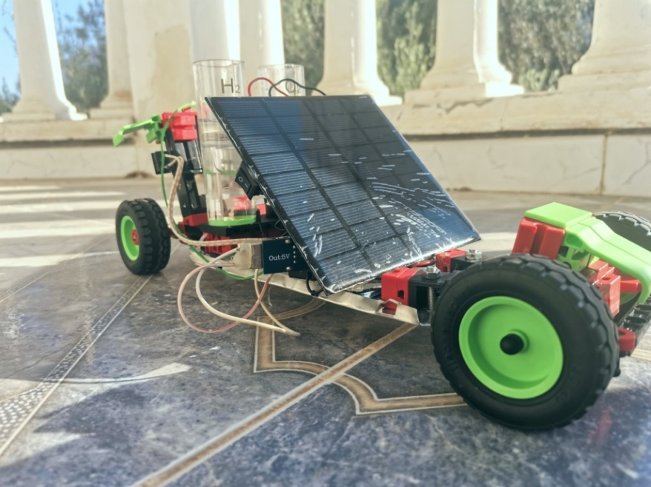

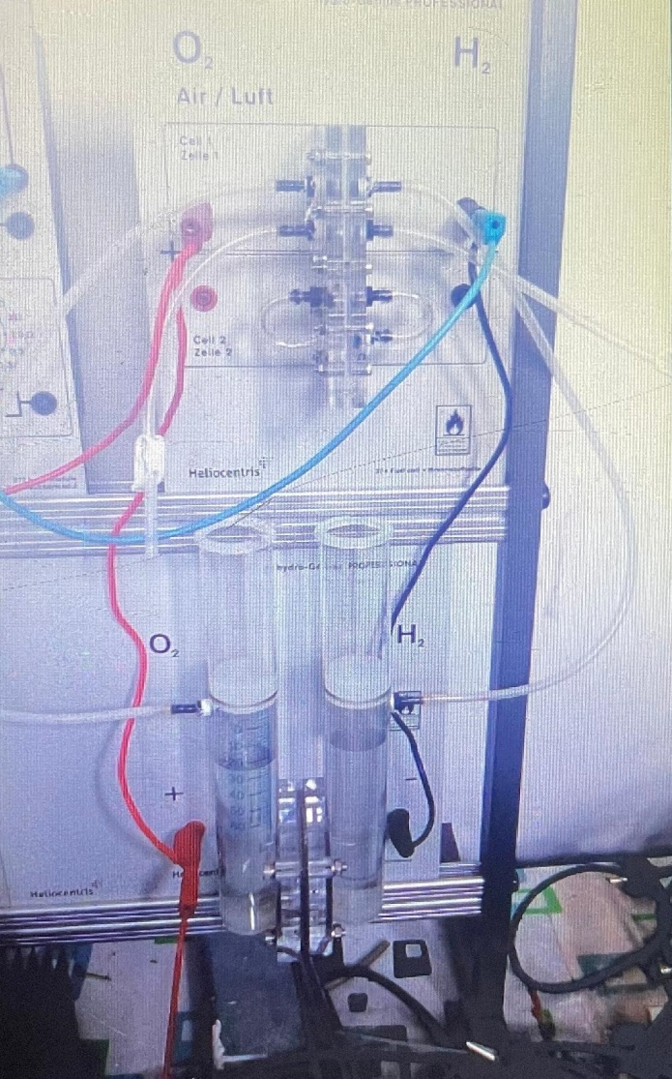
Electric production via Hydrogen Fuell cell

